Tidmarsh
All Persons Trail Tour

This interpretive tour typically takes 45 minutes to one hour.

We invite you to use this printed booklet to enjoy the trail tour.

Tour information is available in several formats:
- You can borrow a copy of the booklet printed in braille, with a tactile map.
- You can download and print your own customized copy of this booklet from our website, in whatever font, size, and color combination you prefer.
- You can take the tour using an audio recording. The audio files are available to download from our website to your own audio device. Or, you can borrow a Victor Stream Reader audio player by contacting us in advance at 508-927-1200.

Please call ahead for information on trail conditions and to find out what items and materials are available for loan.

We gratefully recognize the commitment and generosity of the donors and the accessibility consultants that have made this project possible. They are listed on the last page.
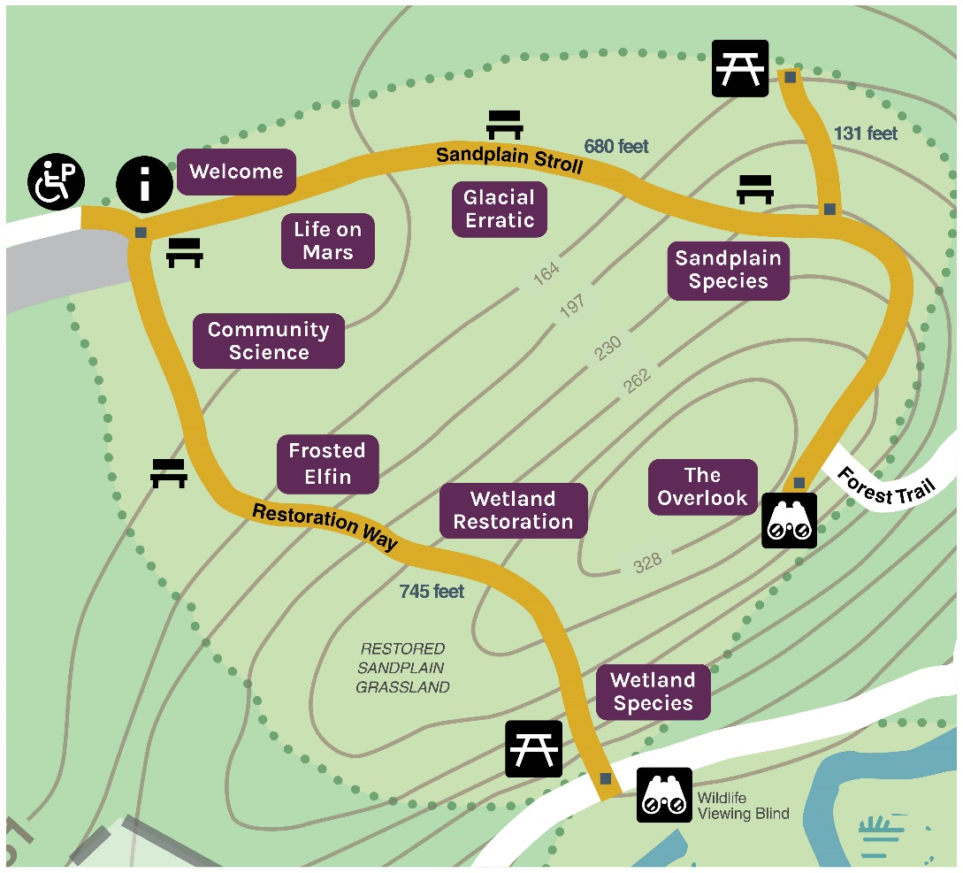

Welcome
Welcome to Mass Audubon’s Tidmarsh Wildlife Sanctuary. Tidmarsh, a historic former cranberry farm, is an important ecological restoration site. Creating a cranberry farm dramatically changed how the ecosystem functioned. Waterways were dammed, and ponds were filled with sand and sediment. In the 1980s, this farm produced 1 percent of Ocean Spray’s annual cranberry crop. When owners Evan Schulman and Glorianna Davenport decided to stop farming, they faced important decisions about the future of this property. Developers were interested in turning much of the property into residential homes, but Evan and Glorianna saw a different future—a future where the land was restored to a more natural state. Evan, Glorianna, Mass Audubon, the Town of Plymouth, the Massachusetts Division of Ecological Restoration, the U.S. Natural Resources Conservation Service, and many other partners came together to make this restoration vision a reality. Today, these ongoing partnerships enable scientists from around the world to study the on-site changes and help other locations undergo similar restoration projects.
This ADA-compliant All Persons Trail at Tidmarsh is approximately 1,400 feet long and surfaced with a stone dust mixture for nearly its entire length. The surface of the trail changes to wooden segments just before the Overlook. It typically takes 45 minutes to one hour to fully experience this sensory-rich All Persons Trail.
There are two sections to this trail:
Sandplain Stroll to the left, explores the past, present, and future of Tidmarsh. This section of trail has a gradual upward pitch as you approach the "overlook."
Restoration Way, to the right, is a journey that explores the science of restoration ecology. This section begins level, gradually declining on the way to the bird blind, becoming reasonably steep towards the end.
Follow the rope guide until you reach the next spherical bead approximately 50 feet ahead. If you choose to follow the journey to the Overlook, the bead will be located on your right. If you choose to follow the journey to the Bird Blind the bead will be on your left.

Sandplain Stroll: The past, present, and future of Tidmarsh
Life on Mars
At the height of Tidmarsh Farm’s cranberry production, this area looked completely different than it does today. As a cranberry farm, this spot was the center of a gravel pit. Massive piles of sand and gravel would tower over people here. This material was used to build the cranberry bogs and farm roads.
Above the interpretive stop marker are two tactile representations of what these changes may have looked like. We encourage you to think about the magnitude of the changes that have occurred as you interact with the models. Both represent a “birds-eye view” of the same landscape area. On the left is a representation of the historic sand and gravel mine. On the right is a tactile model of what the restored landscape looks like today. How does this restored habitat compare to the past?
The material that was mined was also exported throughout Massachusetts, including to famous locations like Fenway Park. The landscape, which resembled the surface of the Red Planet, looked quite different from its natural state. Locals called it “Mars.” Today, this area is a restored sandplain community. Many other habitats are also being restored throughout Tidmarsh Wildlife Sanctuary.
To get to the next stop, continue with the rope guide on the right for 200 feet. Along the way you will encounter some cube-shaped beads that indicate multi-use seating areas are located approximately six feet away on the left side of the trail.

Glacial Erratic
Here is a large glacial erratic boulder left over from the Pleistocene epoch, approximately 20,000 years ago. Tidmarsh, like all of New England, is marked by the effects of the glacial activity that occurred during the Pleistocene. A massive glacier nearly a mile high rested right where you are now. This glacier formed as a result of cooling average temperatures, and both its formation and melting had a major effect in shaping the local area. Explore this boulder and think about how slow-moving ice, over the course of thousands of years, moved this massive rock to where it now rests.
Take a moment to feel, see, and experience this boulder. Do you notice the lichen attached to the sides of this boulder? What do you notice as you observe this lichen and the rock both closely and from far away?
Glaciers shaped the landscape of the Northeast U.S.; sandplains were formed from the sand and debris deposited by melting glacial water. As the habitat changed over time, wildlife species that were well-adapted to the changes moved in or adopted new niches. Some of the plant and animal species adapted to live in this sandplain community are found nowhere else. Their adaptations are evidence that nature is dynamic—always changing over time.
Continue with the rope guide on your right, approximately 125 feet to the next spherical bead. Along the way, there are additional seating areas located on the opposite side of the trail, approximately six feet away from the cube-shaped beads.

Sandplain Species
This meadow habitat supports several interesting species adapted for life in this unique ecosystem. One species found here is the Fowler’s Toad. A life-size tactile model of this small amphibian is located at this interpretive stop. As you explore this model, think about how you would survive if you were an animal in this habitat.
Fowler’s Toads have a call that sounds like “waaah,” or like a bleating sheep. Fowler’s Toads, like other toads, produce a toxin in their skin that helps them avoid being eaten by predators. When a potential predator bites the toad, the toxin causes a particularly bad taste. This strategy may not save every individual toad from being bitten or eaten, but it will protect other individuals, as that predator may avoid hunting these bad-tasting toads in the future.
In this habitat we are reintroducing the Yellow Wild Indigo plant. This bushy, one to two-foot-tall plant with small yellow flowers is used for nectar by a variety of butterfly and moth species, including the endangered Frosted Elfin butterfly. Wild Indigo has unique properties and amazing adaptations for living in this habitat. It can break off at its stem and roll in the wind, depositing its seeds like tumbleweed!
To learn about other examples of biodiversity at Tidmarsh, continue 375 feet to the next interpretive stop with the rope guide on your right. Two additional multi-use seating
areas are located approximately six feet away on the opposite side of the trail from each
cube-shaped bead.

The Overlook
As you continue to follow the rope guide on the right, the stone dust path will soon change to wooden planks. You have arrived at the Overlook, one of the most awe-inspiring locations at Tidmarsh, and one of its highest elevation points. Seating is available on three sides of the Overlook.
As you face this interpretive sign, the sandplain is below you. In the distance to the left are some wetlands. Spend a few moments taking in the experience the Overlook provides. Feel the wind on your face. Smell the hint of salt in the air. Listen for the sounds of wildlife.
If you are lucky, you may hear a majestic Red-shouldered Hawk soaring overhead; their typical call is a loud, clear, two-syllable scream “kee-yer, kee-yer” often repeated in a series while perched or in flight high above the tree canopy. They are especially noisy in March and April during their courtship and mating season.
You may hear the stealthy Great Horned Owl often heard at dusk and dawn, especially in late fall and early winter. The males frequently give a low resonant series of hoots, “hoo hu-hu-hu, hoo! hoo!” The female’s response is usually a little shorter and higher in pitch, and sometimes overlaps slightly with the call of male.
If you’re really lucky, you might hear an Indigo Bunting, a beautiful songbird with richly colored blue feathers, singing a lively series of paired phrases that sound like “sweet-sweet, chew-chew.” They call from fairly high in trees, often at a forest edge or the edge of a field or powerline, and they tend to sing even in hot weather and often late into summer.
As this space continues to be restored and recover, species will return and thrive. What might the future Tidmarsh look like?
A fully restored Tidmarsh will have River Herring using the Tidmarsh wetlands as a highway to their spawning grounds elsewhere in Plymouth. This will enable positive trophic effects, or waves of change, throughout the food web. Species on the coast that feed on River Herring, such as Osprey, will thrive. Those species that feed on inland River Herring will also benefit, continuing a cycle of cause and effect. On and on, these changes will continue to affect species within and around Tidmarsh. The restoration of Tidmarsh will also enable trophic effects that involve our pollinators, nesting birds, and amphibians. But these changes will take time, so we encourage you to visit often to observe new developments.
To return to the rope guide from the Overlook, orient yourself so the platform railing is on your
left. Eventually the railing will join the rope guide. Follow this rope guide all the way back to the Welcome Sign.

Restoration Way: the science of restoration ecology
From the Welcome Sign, keep the rope guide on your left. Proceed until you reach a spherical bead after approximately 50 feet.
Community Science
There is a bird box located directly above this sign. The front of the box features a door that can be opened by lifting the handle. Inside is a life-size replica of an Eastern Bluebird. Mass Audubon participates in NestWatch, which is led by Cornell University. For this community science initiative, trained staff and volunteers identify bird species using the nest boxes, and then count and track how many of the eggs produce young that survive to adulthood. Eastern Bluebirds are one of the species we monitor. As an insectivore, an animal that feeds on insects, Eastern Bluebirds provide a particularly important data set to help scientists understand the dynamics of their ecosystem. Their song is a melodious series of three to four gurgling notes, sometimes with a dry chattery quality. Their most common call is a note given when perched or in flight, a soft, almost sweet, “tur-a-wee or chur-wi.”
Community science projects are one of the ways in which habitat restoration efforts can leverage partnerships with other organizations, groups, and community members. NestWatch tracks the status and trends within nesting bird populations throughout the country, providing data that help scientists understand more about the reproductive biology of birds. Mass Audubon staff and our associated partners similarly track data associated with the Tidmarsh restoration efforts. One of our partners, Living Observatory, provides opportunities for the public to see these data and any trends in real time on their website.
Every partner who participates in our restoration efforts has an important role to play: scientists, property workers, educators, office staff, and our numerous volunteers. Without these partnerships and the skills of these partners, a project of Tidmarsh’s magnitude simply wouldn’t be possible. We are so appreciative of those who have made this restoration effort a reality.
There is a large multi-use seating area approximately six feet away on the right side of the trail with two separate benches and a large glacial erratic in between them. To continue, follow the rope guide on your left to reach the next spherical bead 125 feet away.

Frosted Elfin
Biodiversity loss is an ever-present threat to our planet. Every day we are losing species to extinction, which challenges the resiliency of ecosystems. Ecosystems worldwide require a diversity of species—everything from microbes and bacteria to fungi, plants, and animals. Every day, individuals are working around the world to save threatened and endangered species, protect the habitats and spaces that they live in, and ensure that their populations can thrive for years to come.
Here at Tidmarsh, staff and volunteers are working to restore habitat for an important pollinator species that is found in small pockets throughout the state. The Frosted Elfin is a small, brown butterfly that exemplifies the importance of biodiversity. Pollinators are animals that are fundamental to plant reproduction; they help transport pollen. Pollinators account for anywhere from 75 percent to 95 percent of the pollination of all flowering plants. Many of the plants we rely on for food are only pollinated by these animals.
Frosted Elfins rely on habitats that provide space for their primary food sources, wild indigo and lupine. To survive in their habitats, Frosted Elfins have developed some unique adaptations that you can explore in this tactile display. In the middle of the display is an enlarged model of a Frosted Elfin. With a finger, follow each carved path from the butterfly to an object that we often use for similar reasons. Can you identify which object matches which aspect of the butterfly’s physiology and behavior? We will give you a few clues. One object is associated with their long proboscis, the butterfly’s extendable mouth part. Another represents the fine hairs on their legs. Another is associated with their camouflage. The last item is associated with their overwintering behavior.
To continue to the next stop, follow the rope guide on your left for 225 feet to the next spherical marker. Along the way, additional multi-use seating areas are located approximately six feet away on the opposite side of the trail from each cube-shaped square bead.

Wetland Restoration
Above this interpretive stop marker are two tactile models that explore the restoration work that has occurred at this site. On the left is a model of a bird’s-eye view of Tidmarsh as it would have looked like when the waterways were dammed for cranberry farming. The model on the right features this same area after the dams were removed. You can both feel and see the differences within each model. What specifically do you notice when you compare the two?
You may notice the stream’s ability to flow improved after the dam was removed, and the surrounding area changed. Take a few moments to think about these different types of waterways. Why would it help the ecosystem to have restored, flowing streams rather than artificial bodies of water created by dams?
Wetlands are valuable to plants and wildlife as homes, refuges, places to find food, and nurseries to raise young. We also rely on wetlands for water filtration, storm surge protection, economic and recreational resources, and cultural and artistic inspiration. The wetlands within Tidmarsh lost their natural function when they were altered to create cranberry bogs. As the streams and bodies of water were dammed, filled with sand, and then altered with chemicals to protect the harvest, these important ecological resources could not function naturally.
On the tactile models, you can see the magnitude of change after the dams were removed. Wetlands are natural sponges that absorb water; this is especially important during storms and high-volume water events. When a wetland is altered, it no longer functions in essential ways that keep our communities safe and local habitats healthy.
To continue, follow the rope guide on your left for 175 feet to reach the next spherical marker. Again, as with previous interpretive stops, there are some multi-use seating areas along the way, located on the opposite side of the trail, marked by a cube-shaped bead. As you near the next interpretive stop, the trail will have a steeper decline.

Wetland Species and Bird Blind
With this sign on the left, there is a structure called a Bird Blind approximately six to seven feet ahead. Bird blinds enable us to observe animals while remaining hidden so we don’t distress them. We invite you to spend time observing the wetland just behind this structure. What do you notice when you’re within this space? How do you feel knowing that you are hidden from view? What do you hear? Smell? See?
The bird blind contains a selection of full-size tactile biofacts also associated with wetland habitats. There are replica skulls of two species, the River Otter and the Great Blue Heron. Along with the skulls are some footprints of species sometimes encountered along the edge of the water. Feel free to spend a few moments exploring these objects; all are labeled.
Wetlands are dynamic areas with species adapted to seasonal changes of water temperature, water level, and organisms present. River Otters belong to the Mustelidae family, which also includes mink, badgers, weasels, ferrets, and wolverines. River Otters spend their time hunting fishes, amphibians, mollusks, turtles, and crayfish. They are known as a playful species, but activities that look like play to humans actually help the otters hone their hunting skills.
Great Blue Herons are adapted to stalking shorelines with their long slender legs. They can easily sneak up and pluck their prey out of the water with their tweezer-like bill. These adept hunters eat fish, frogs, and an occasional turtle. Great Blue Herons make deep-throated, harsh croaks that sound like “fronk! fronk! fronk!” when in flight or when first taking flight. These calls are often heard at night near wetlands.
When observing a wetland, we often expect to see ducks, muskrats, and other common inhabitants. Coyotes and raccoons will sometimes wander close by, leaving their footprints. You can explore the tactile models of these wetland visitors below the replica skulls.
When you are ready to go back to the main path of the All Persons Trail, return to the display featuring the skulls and footprints. With the tactile display on your left, the rope guide will start again on the right, approximately six feet away.
Here you have two choices:
A sheltered picnic pavilion with seating is available nearby. With the tactile display on your left, follow the path for approximately ten to fifteen feet, the pavilion will be located to your right. We invite you to enjoy this space and enjoy the sights and sounds here near the water. Please be careful, there is a steeper incline surrounding the picnic area because it is dug into the hillside.
Here you can also take this trail back to return to the trail entrance. Follow the rope guide on the right and it will guide you back.

We hope you enjoyed your visit and learned about the historic and present-day operation of Tidmarsh Wildlife Sanctuary. We invite you to return in other seasons, and also to visit some of Mass Audubon’s other All Persons Trails. For more information on our All Persons Trails, our commitment to accessibility, or to provide feedback about your visit to this trail, please visit www.massaudubon.org/accessibility.

Special thanks to the accessibility consultants, volunteers, and all others that helped to make this project possible.

Mass Audubon thanks the following organizations and individuals for their
generous support:
- Jerry Berrier  - Mark Priest  - Chris Arsenault  - Perkins School  - Living Observatory  - Alvarium Foundation  - Tidmarsh volunteers | - TerraCorps Service members  - MassTrails  - USDA Forest Service  - Charter Contracting Company, LLC  - Convergint  - Anonymous Donors

